Follow these steps in order to create your own Twitter application. An application is a way to interact with the Twitter web-service, and gain access to a variety of resources. Without an application to retrieve data from Twitter, your Social-Network-Harvester (Aspira) account will not be able to search new content for you!

1. Assuming you already have a Twitter account, log into it, go to the settings page and add a valid phone number to the account. If you already have one configured, you can skip this step.

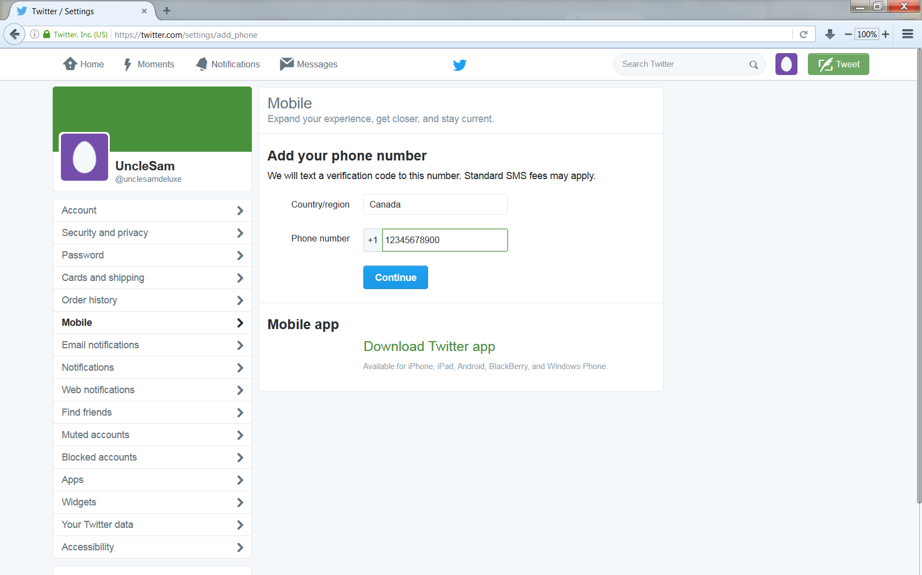

1. Next, type in the URL <https://apps.twitter.com/> and click on “Create New App”

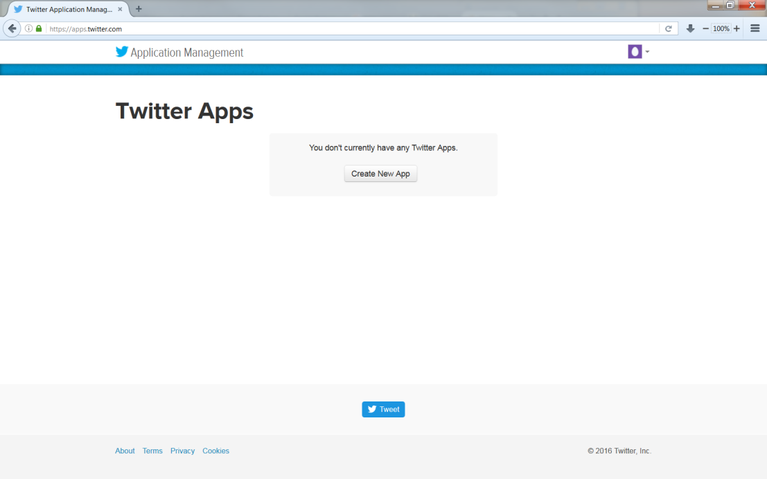

1. Type in your application name (it will have no influence on your SNH account), a short description and your website’s URL. If you don’t own a website, just type in <http://aspira.ulaval.ca/>. Leave the field *Callback URL* empty.

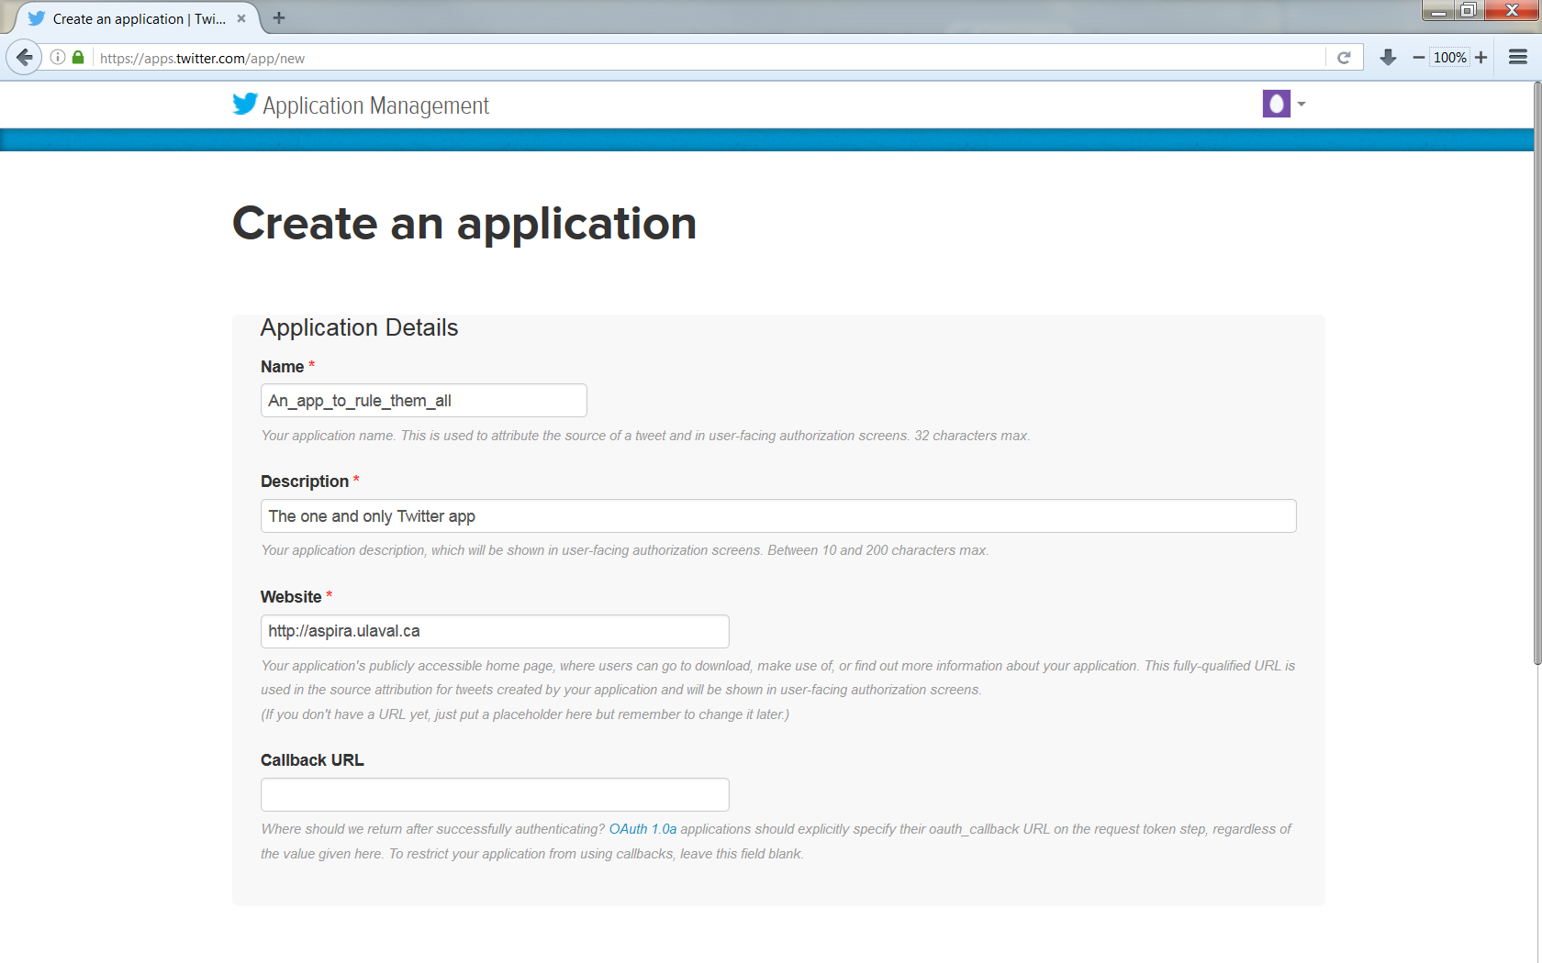

1. Scroll down the page, read and agree to the *Twitter Developer Agreement* and create your Twitter Application.

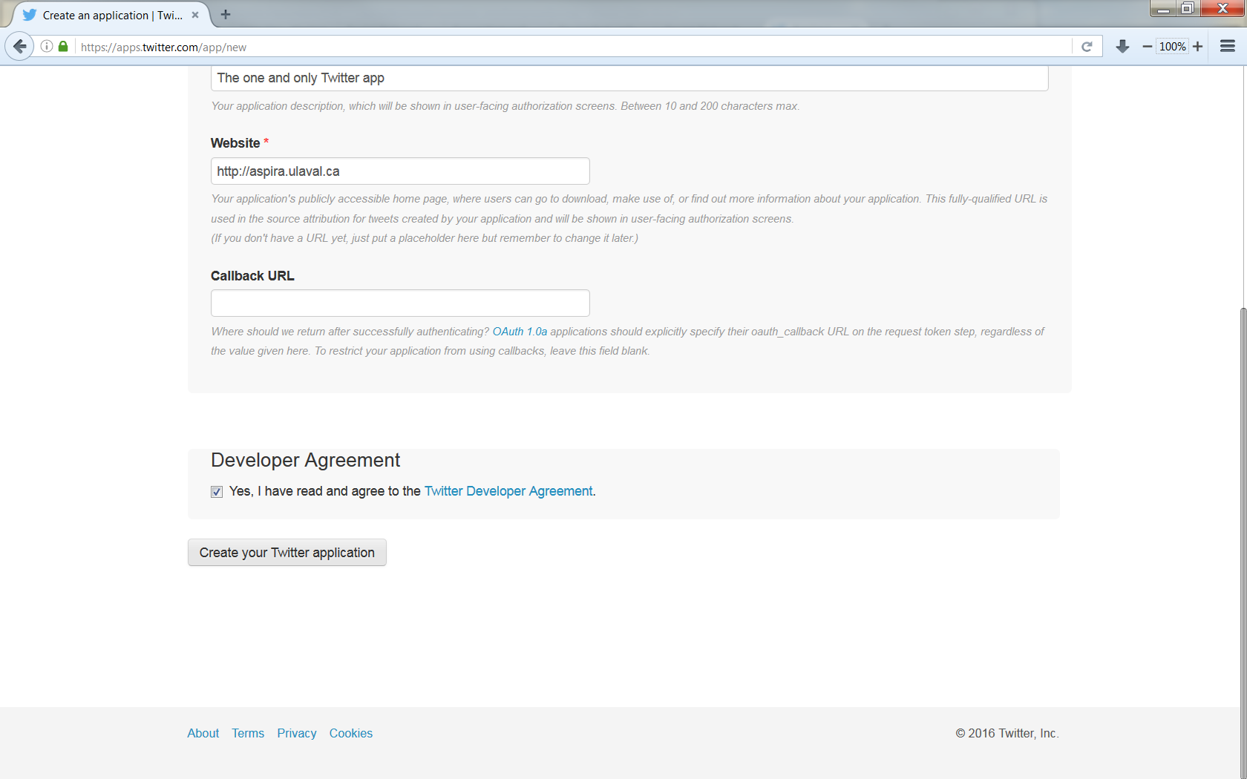

1. Once created, click on the *Permissions* tab and change the access setting to *Read Only*. Click on *Update Settings*.

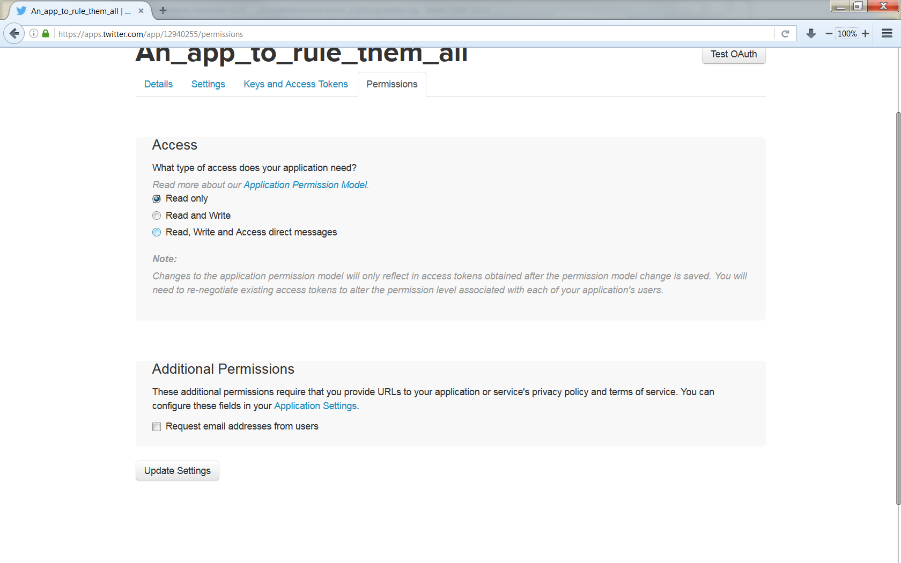

1. Click on the *Keys and Access Tokens* tab and scroll down to the *Access Token* section. Click the link to generate an access token pair. You should see a page like below.

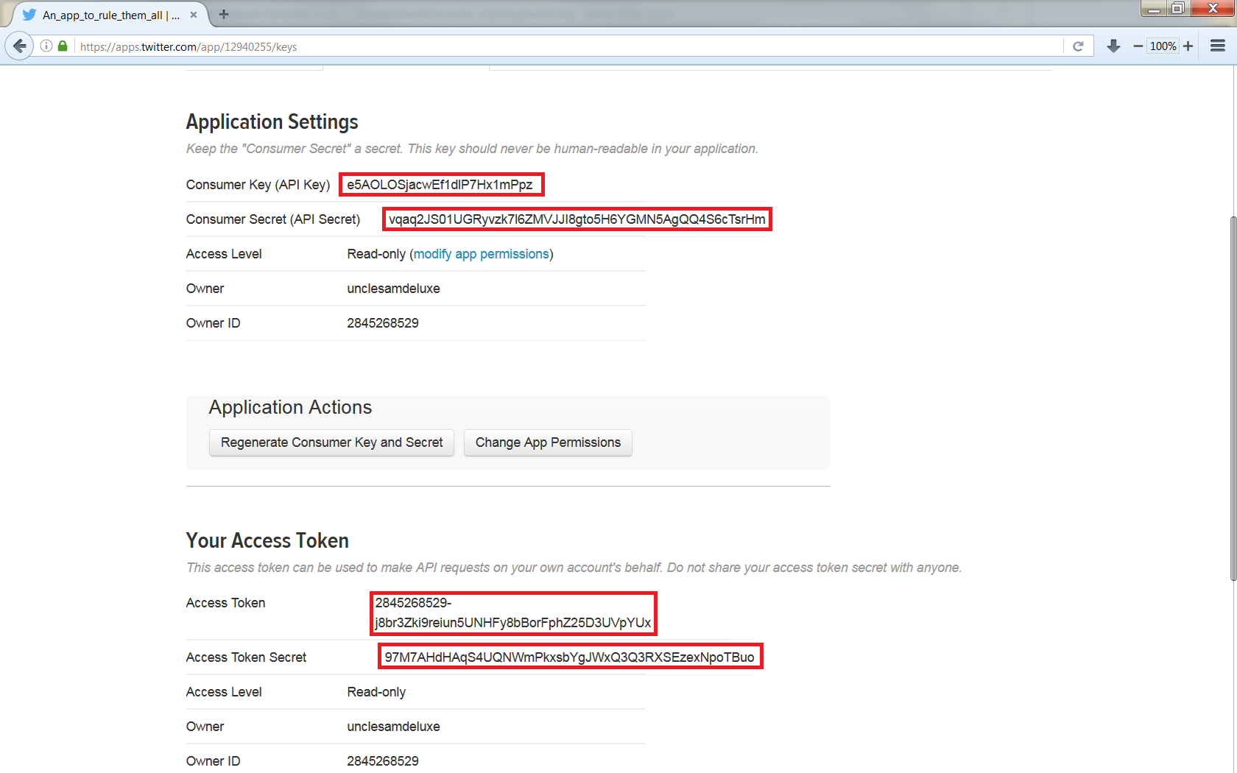

Copy and paste the four highlighted codes into your Aspira’s settings page, in the Twitter app section. Finally click on *Save changes* to save. Congratulation, you can now add Twitter users and hashtags for Aspira to harvest for you!